

School of Computer Sciences, Universiti Sains Malaysia

Semester 1, Academic Session 2021/2022

**CAT402: Professional and Technopreneurship Development**

**Business Plan**

**Company: Edu.AI**

| Name | Matric Number | Email Address |
| --- | --- | --- |
| Tang Wen Shuen | 142623 | wenshuen_tang@student.usm.my |
| Chan Siang Sheng | 142413 | siangsheng.chan@student.usm.my |
| Suen Kee Xian | 142215 | keexian1134.usm.my@student.usm.my |

Lecturer’s Name: Mr. Azlan Osman

Date of Submission: 22 January 2022

**Edu.AI**

Tang Wen Shuen

Copy Number One

**CONFIDENTIAL**

**Edu.AI**

Tang Wen Shuen

Chan Siang Sheng

Suen Kee Xian

(604) 233-4567

info@edu.ai

Copy Number One Assigned to Mr Azlan Osman

CONFIDENTIAL

Do not make copies of this document

**TABLE OF CONTENTS**

**Executive Summary** **1**

**Business Description** **2**

**Products** **3**

**Marketplace Analysis** **5**

Potential Client Base for Eddie 5

Competitor Analysis 5

Overview of Marketing and Sales Strategy 7

**Operational Plan** **8**

Web Site Operations 8

**Financial Plan** **9**

Pro-Forma Income Statement 9

Cash Flow Statement 10

Pro-Forma Balance Sheet 11

Break Even Analysis 12

Financial Ratio Analysis 13

**Management Plan** **14**

The Edu.AI Management Team 14

The Edu.AI Advisory Board 15

Risk Identification 15

Risk Countermeasure 16

Exit Strategy 17

**Appendices** **18**

Exhibit A: Company Official Website 18

Exhibit B: Eddie’s Features 20

**References** **23**

## Executive Summary

Edu.AI begins both online and onsite operations in January 2021 to offer an AI-assisted smart education system. Our company aims to bring the AI-assisted smart education system accessible by any educational institutions that wish to implement it.

Edu.AI’s projected total sales for the first year of operations are RM 120,000. Sales are projected to increase 15% annually for the next three to five years. Edu.AI expects to break even in the firstyear and be profitable in the secondand remaining years.

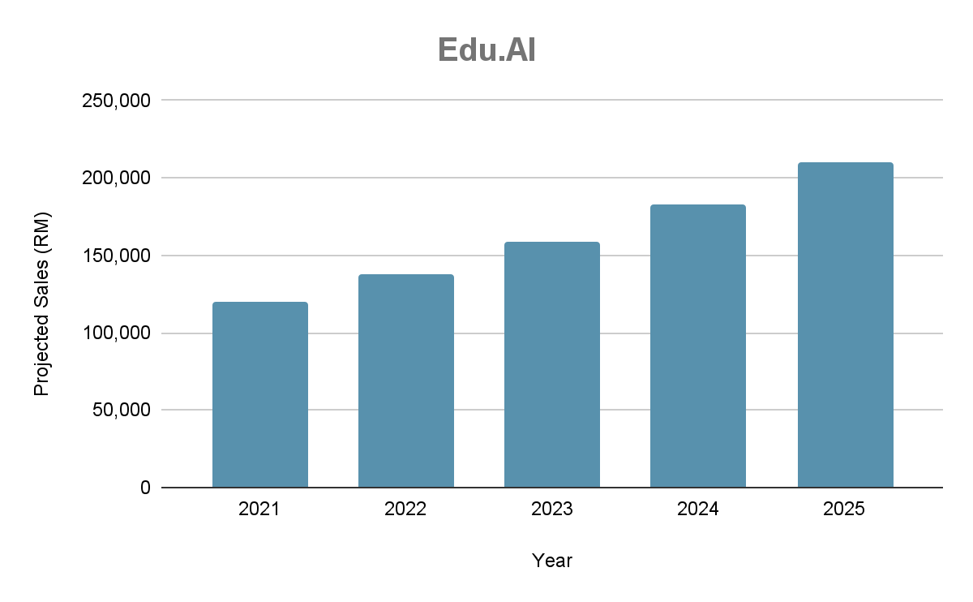

The market for online learning systems is expected to grow at exponential CAGR (Compound Annual Growth Rate) of over 21% between 2021 and 2027. Edu.AI has 3 major competitors in the online learning systems. Our total focus on embedding the AI-assisted smart features such as smart attendance tracking, lecture keywords extraction, and student’s behavior tracking into the existing platform gives Edu.AI a competitive advantage in this marketplace. Edu.AI also attempted to expand its market through some marketing and sales strategies such as social media advertisement, promoting through schools and email marketing.

Edu.AI’s potential clients are 1) public and private educational institutions, 2) private tutoring institutions and 3) other institutions in which the usage fits. Edu.AI is also prepared to offer specialized features as requested to each of these three potential client markets.

With a top management team, strong customer service representatives and technical team, an easy-to-use website, and a strong marketing plan, Edu.AI is poised to exploit the AI-assisted smart education system marketplace.

Initial funding is done through long term loans from financial institutions. The product is placed online and available on the existing platforms’ app marketplace. The revenue is earned through products’ monthly subscription fees. Cost is minimized through the elimination of physical stores. Most of the costs are being used for office rental, software development, and online services subscriptions.

## Business Description

Edu.AI is a privately-owned provider of the AI-assisted smart education system. Created in January 2021 as a sole proprietorship, Edu.AI develops and provides the AI-assisted smart education system based on the client requirements.

**Our vision:**

*Be the best AI-assisted smart education system provider in the industry, by equipping with the latest AI technologies.*

**Our mission:**

*To make the AI-assisted smart education system accessible by any educational institution that wishes to bring changes to the existing mode of Teaching and Learning.*

**Management team:**

Tang Wen Shuen, Co-founder and President of Edu.AI

Chan Siang Sheng, Co-founder and Chief Administrative Officer

Suen Kee Xian, Co-founder and Chief Information Officer

**Contact information:**

Edu.AI

3-23-3 Suntech @ Penang Cybercity

Lintang Mayang Pasir 3, Bayan Baru 11950

Pulau Pinang

(604) 233-4567

Email address: info@edu.ai

Web site: www.edu.ai

## Products

Edu.AI currently developed one product: Eddie, the AI online learning classroom assistant.

**Eddie**

Since the COVID-19 pandemic hit hard globally around the beginning of the Year 2020, most educational institutions worldwide had to shift to the online learning mode to control the infection rate. However, there are some issues in the online learning mode when compared to the face-to-face learning mode.

One of those issues includes the inaccuracy in taking online attendance. The conventional online attendance system normally requires only students to submit the attendance code or take the attendance on their own. This means that the students are not required to attend the online class to take their attendance as long as they are able to obtain the attendance code or submit the attendance on their own.

Another issue would be the discrepancy between the contents delivered and the knowledge absorbed by the students in the online class. Students might not be able to pay full attention to the online class which causes them to miss out on part of the important knowledge. Besides, students could also have a weak internet connection which makes them unable to attend the online class smoothly.

One more issue would be the behaviours of the students in the online class. Lecturers are able to notice the students’ behaviour much easier during face-to-face class. However, this would be a harder task in the online class as lecturers have difficulty in checking out the students’ situation in the online class. This might cause the lecturers to feel hard to notice the students who have problems in following the classes and plan out the suitable teaching method in the online classes.

Eddie, our AI online learning classroom assistant could be a good help to overcome those issues in the online class through 3 features.

The first feature is the **Online Attendance Tracking System** through the use of face recognition technology. The attendance of the given student is only marked when his/her face is detected in the online class. Even if the student attempted to fool the system with an image of themselves, our system is trained smart enough to differentiate between the face in the image and the face in the real environment.

The second feature of Eddie would be the **Lecture Keywords Extraction System**. This system makes use of the keywords extraction feature to extract out the key points during the lectures and format them in a readable format that can be accessed freely by the students who enrolled in the relevant courses. Through this way, even if the students have issues in attending the online class, they can still understand the core idea of the lecturers through reading the extracted notes.

The third feature would be the **Student Behavior Tracking System**. This system utilizes facial emotion detection and eye level tracking features to keep track of students’ behaviour in the online class. For example, the students could not pay attention to the class when their eyes are away from the webcam over a period of time. It’s also a sign of being unable to understand the lesson conducted in the class when the students’ face shows signs such as eyebrows pulled together. The system will also send a notice to the lecturer when there are students who are not paying attention to the class or unable to follow the class.

Other than the features mentioned above, we could also add in any other additional features requested by the client as long as they are achievable. The features mentioned above could also be modified based on the clients’ requirements as well.

In order to have an experience on the benefits that could be brought by Eddie, the client just needs to install it to the supported web conference tools. All of these features are subscription-based and the client only needs to pay based on what they used. Since each feature could be customized further to the client’s specific needs and they could also request additional features, Edu.AI will apply additional surcharges on the subscription fees based on the degree of modification or number of additional features.

## Marketplace Analysis

Ever since the beginning of COVID-19 pandemic, the market for E-learning platforms has been continuously rising even until today. According to Global Market Insights[1], the E-learning market size has surpassed USD 250 billion in 2020 and is anticipated to continuously grow at an exponential CAGR of over 21% between 2021 and 2027. There are several reasons for this:

* The emergence of AI-enabled e-learning solutions which helps in the development of a smarter e-learning system.
* The closure of public and private schools due to the need for social distancing.
* The huge advancement in various technological fields such as Cloud Computer and Virtual Reality.

### Potential Client Base for Eddie

The potential client base for Eddie would be both public and private educational institutions ranging from basic level educational institutions such as primary schools to higher level educational institutions such as colleges and universities which implement online learning curriculum. Eddie is also open to any private tutoring institutions such as tuition centers as well as other institutions in which the usage fits. According to the statistics gathered by ThinkImpact[2], since 2020, 98% of universities have moved their classes online. It is also estimated that about 75% of schools are planning to operate online in 2021.

### Competitor Analysis

As the e-learning market continues to grow, there are several e-learning related products that are launched to take advantage of the rising market.

**1. Udemy**

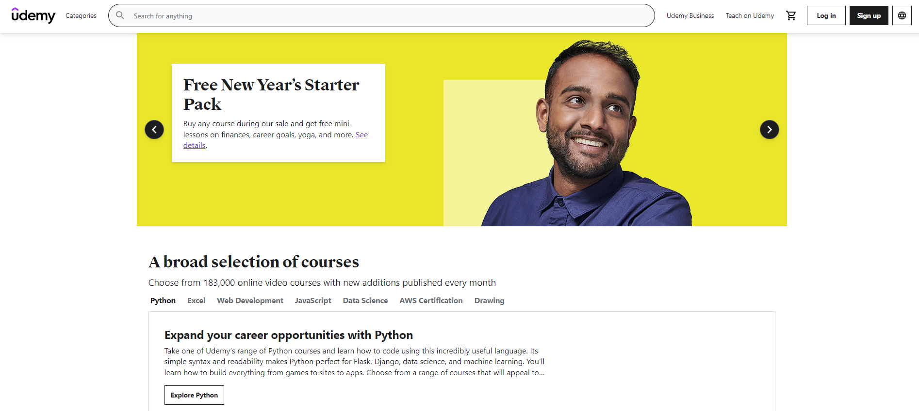

Udemy is an online teaching and learning marketplace with over 183000 courses and 40 million students. There are various courses offered on Udemy that are taught by experts from various fields such as computer science, physics, biology and art. For each course, the students are offered learning materials as well as lesson videos that make use of the learning materials to enhance the students' understanding in the course they sign up for.

To gain access to any of the courses on Udemy, most students will have to pay an entry fee that gives them access to the course materials and also teaching videos. Some of the entry-level courses though are available for free. There are also discounts and sales during special occasions such as Christmas and New Year that makes the courses more affordable to the students.

**2. Coursera**

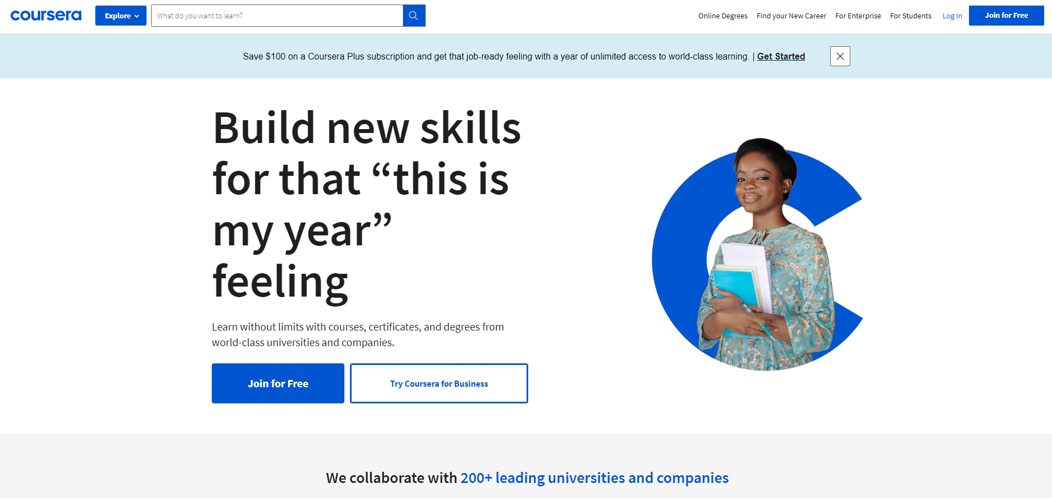

Similar to Udemy, Coursera is an online course provider that provides users with subscriptable courses in various fields such as computer science and art. There are currently more than 82 million learners and more than 6000 campuses, businesses and governments that came to Coursera to access its learning materials. The difference between Coursera and Udemy is that instead of focusing more on lesson videos, Coursera also incorporates practical tutorials to further enhance the students' understanding in their respective courses with a scoring system that requires the user to obtain a certain points in order to pass the course.

Similar to Udemy, it is also necessary for students to pay an entry fee for them to gain access to any of the courses and their relevant course materials in Coursera. The main difference between Coursera and Udemy is that in Coursera, users are allowed to apply for scholarships that allows them to apply for courses without the need to pay the entry fee.

**3. Google Classroom**

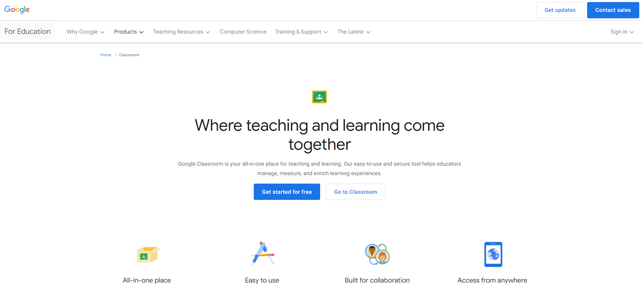

Google Classroom is a free blended learning platform for educational institutions with a goal to simplify the creation, distribution and grading of assignments. Its main purpose is to ease the process of sharing lesson materials between the students and also the teachers. The students in the same classroom can also communicate easily with the teachers regarding any of their assignments or other course-related questions.

The main advantage and selling point of Google Classroom is the integration of a variety of other Google Applications for Education. With Google Classroom, students gain access to the use of other Google Drive services such as Google Docs, Google Sheets, Google Slides for assignment purposes. The teachers also gain access to the use of Google Meets to conduct their teaching sessions. The schedule for different class sessions and assignment deadlines will also appear on the respective Google Calendar tied to the same account used in the Google Classroom.

### Overview of Marketing and Sales Strategy

### 

To promote Eddie to a larger amount of audience, these are the marketing strategies that we will be implementing.

**1. Social Media Advertisement**

We will promote our product on various social media platforms such as Facebook, Twitter and Instagram. We will also advertise our product through Youtube Ads on videos that are relevant to our products such as coding videos. On Facebook, we will create a page for Eddie with the product description and also subscription details.

**2. Promotions through Schools**

As the main targeted audience of our product are students and teachers, we will also go around to different schools, ranging from elementary schools to universities, to promote our product. We will introduce our product to the audience, explaining to them how it works and what its benefits are.

**3. Email Marketing**

We will be sending emails to our potential clients such as school teachers and also students to promote our product. These emails can be in the form of newsletters and feature launches to attract their attention.

## Operational Plan

Edu.AI has a service center located in Suntech@Penang Cybercity of Bayan Baru, Pulau Pinang. The service center is essential to provide customer services and acts as a business operational location for the development of Edu.AI’s product. Executives of Edu.AI can be categorized into 2 different teams which are the customer services team and the development & technical team.

Edu.AI clients can contact us through email or call and our customer service team will attend to their issue or request. Each client will be attended by one customer service executive to help with their request such as product issues, transaction issues, feedback or improvement requests, etc.

Each customer service executive is responsible for:

* Listen and understand to customer’s issue or request
* Resolve customer’s issue
* Refer the issue to a higher rank executive or technical team if requires
* Provide deliberate and clear explanation to customer
* Openly accept any feedback or request as consideration under the company’s business plan
* Complete the client services with a mutual understanding closure

In addition to the customer service team, Edu.AI’s development & technical team also has their own role under the operational plan. The development & technical team of Edu.AI mainly focus on the development and maintenance of Edu.AI’s product, for instance, Eddie. Besides that, they are also responsible for aiding the customer services team whenever the issue from clients is technical-related.

Each development & technical executive is responsible for:

* Suggest new product initiatives
* Develop new product
* Maintain the system of existing product
* Bug fixes and update patches with improvement to existing product
* Attend to any technical issue rises from clients
* Resolve any cyber security attack
* Manage risk assessment

### Web Site Operations

The business website of Edu.AI is owned and developed by our own development team, the hosting of the website is done by Exabytes Network Sdn. Bhd which is a Malaysia web hosting company that has multiple branches located in Penang, Kuala Lumpur and Selangor. The headquarter of Exabytes is located in Penang which is close to Edu.AI’s service center, hence this is easy for us to contact or have discussions physically. Edu.AI’s website is hosted in Exabytes Malaysia Data Center’s servers that provide SLAs in Malaysia.

## Financial Plan

### Pro-Forma Income Statement

| **Edu AI** | | **Income Statement** | |  |
| --- | --- | --- | --- | --- |
| For the Years Ending [Dec 31, 2021] | | | |  |
|  |  |  |  |  |
| **Revenue** | |  | **2021** |  |
|  | Sales revenue | RM | 120,000 |  |
|  | Service revenue |  | 14,400 |  |
| **Total Revenues** | |  | **134,400** |  |
|  |  |  | [42] |  |
| **Expenses** | |  |  |  |
|  | Advertising | RM | 2,000 |  |
|  | Employee benefits |  | 10,000 |  |
|  | Furniture and equipment |  | 30,000 |  |
|  | Interest expense |  | 1,000 |  |
|  | Maintenance and repairs |  | 24,000 |  |
|  | Office supplies |  | 2,000 |  |
|  | Rent |  | 10,000 |  |
|  | Research and development |  | 15,000 |  |
|  | Salaries and wages |  | 30,000 |  |
|  | Software |  | 6,000 |  |
|  | Web hosting and domains |  | 3,000 |  |
|  | Other |  | 0 |  |
| **Total Expenses** | |  | **133,000** |  |
|  |  |  |  |  |
|  | Net Income Before Taxes |  | 1,400 |  |
|  | Income tax expense | RM | 1,220 |  |
|  |  |  |  |  |
| **Income from Continuing Operations** | | **RM** | **180** |  |
|  |  |  |  |  |
| **Net Income** | | **RM** | **180** |  |
|  |  |  |  |  |

### Cash Flow Statement

### 

| **EduAI** | | |
| --- | --- | --- |
| **Cash Flow Statement** | | |
|  | | |
|  | For the Year Ending | 12/31/21 |
|  | Cash at Beginning of Year | 2,000 |
|  |  |  |
| **Operations** | |  |
| Cash receipts from customers RM | | 134,400 |
| Cash paid for | |  |
|  | Research and Development | (15,000) |
|  | Server Maintenance and Repairs | (10,000) |
|  | Wage expenses | (40,000) |
|  | Interest | (1,000) |
|  | Income taxes | (1,220) |
| Net Cash Flow from Operations | | **67,180** |
|  |  |  |
| **Investing Activities** | |  |
| Cash paid for | |  |
|  | Purchase of property and equipment RM | (42,000) |
|  | Making loans to other entities |  |
| Net Cash Flow from Investing Activities | | **(42,000)** |
| [42] |  |  |
| **Financing Activities** | |  |
| Cash receipts from | |  |
|  | Borrowing RM | 18,000 |
| Cash paid for | |  |
|  | Repayment of loans | (10,000) |
|  | Dividends | (10,000) |
| Net Cash Flow from Financing Activities | | **(2,000)** |
|  |  |  |
| Net Increase in Cash | | **23,180** |
|  |  |  |
|  | Cash at End of Year | 25,180 |

### 

### Pro-Forma Balance Sheet

| **Assets** | |  | **2021** |
| --- | --- | --- | --- |
| ***Current (Short Term) Assets*** | | |  |
|  | Cash and Cash Equivalents |  | 25,180 |
|  | Accounts receivable |  | 20,000 |
|  | Tax Receivable |  | 700 |
|  | Other receivables |  | 1,500 |
|  | Short-term investments |  | 2,000 |
| *Total current assets* | |  | 49,380 |
| ***Fixed (Long-Term) Assets*** | |  |  |
|  | Long-term investments |  | 9,000 |
|  | Property, plant, and equipment |  | 50,000 |
|  | Intangible assets |  | 15,000 |
| *Total fixed assets* | |  | 74,000 |
|  |  |  |  |
| **Total Assets** | |  | **123,380** |
|  |  |  |  |
| **Liabilities and Owner's Equity** | | |  |
| ***Current Liabilities*** | |  |  |
|  | Accounts payable |  | 7,460 |
|  | Short-term debt repayment |  | 2,500 |
|  | Income taxes payable |  | 1,220 |
|  | Accrued salaries and wages |  | 40,000 |
|  | Current portion of long-term debt |  | 4,000 |
| *Total current liabilities* | | | 55,180 |
| ***Long-Term Liabilities*** | | |  |
|  | Long-term debt |  | 50,000 |
|  | Deferred income tax |  | 1,200 |
|  | Other |  | 2,500 |
| *Total long-term liabilities* | | | 53,700 |
| ***Owner's Equity*** | |  |  |
|  | Owner's investment |  | 5,000 |
|  | Retained earnings |  | 9,500 |
| *Total owner's equity* | | | 14,500 |
| **Total Liabilities and Owner's Equity** | | | **123,380** |

### Break Even Analysis

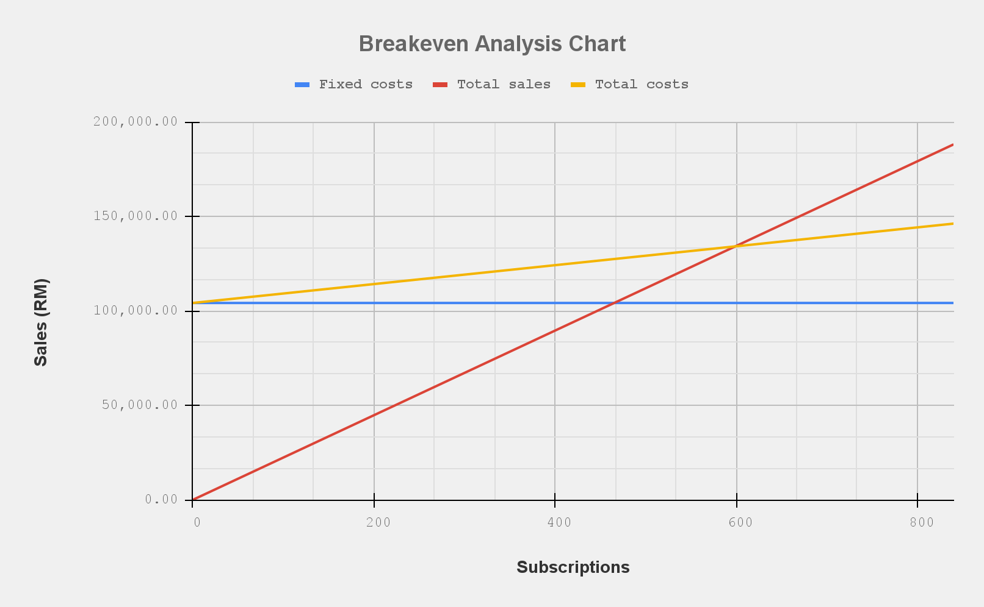

| **Components** |  |  | **RM** |
| --- | --- | --- | --- |
| **Sales price per subscription** | | | 224.00 |
| **Variable costs per unit** | | | 50.00 |
| **Total Fixed Costs** | | | 104,220.00 |
| **Breakeven Point (subscriptions)** | | | 599.00 |
| **Breakeven Point (RM)** | | | 134,170.00 |

### Financial Ratio Analysis

| **Liquidity ratio** | |
| --- | --- |
| Current Ratio | 0.89 |
| Quick Ratio | 0.82 |
| **Asset Management Ratio** | |
| Accounts Receivable Turnover | 10.44 |
| Days of Accounts Receivable Turnover | 34.48 |
| Current Asset Turnover | 2.11 |
| Turnover of Fixed Assets | 1.41 |
| Total Asset Turnover Ratio | 0.85 |

| **Solvency Ratio** | |
| --- | --- |
| Asset-liability Ratio | 88.25% |
| Equity Ratio | 11.75% |
| **Profitability ratio** | |
| Gross Profit Margin | 77.68% |
| Return on Assets | 0.15% |
| Net Profit Margin | 0.13% |
| Return on Equity | 1.24% |

## Management Plan

The Edu.AI organization structure, as shown in the following illustration, enables Edu.AI to continue providing the best quality client services and producing a better product that is highly sought after by the customer market.

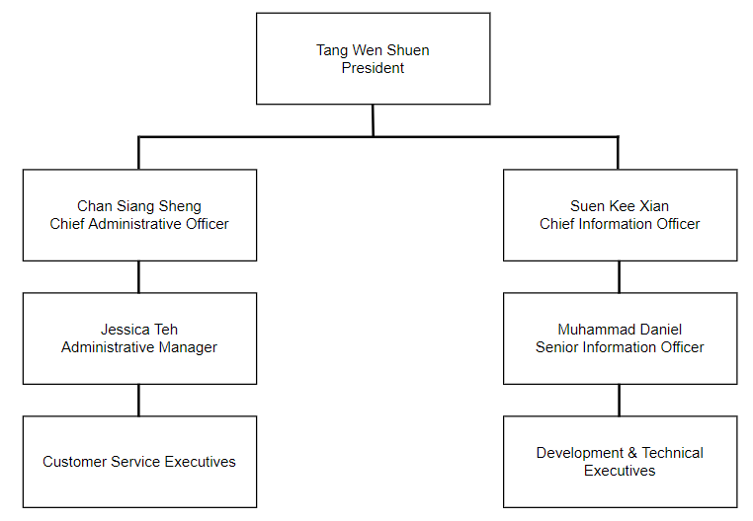

### The Edu.AI Management Team

**Tang Wen Shuen** Tang Wen Shuen is graduated from University of Science, Malaysia

as a Computer Science degree holder. He has some experience in both

the Artificial Intelligence, Web Development and Software

Engineering fields. As the president, he is responsible for making the business decisions and leading the company in delivering the best AI products in the education field.

**Chan Siang Sheng** Chan Siang Sheng is a graduate of the University of Science, Malaysia

with a Bachelor of Computer Science degree. He has knowledge in

Software Engineering as well as Artificial Intelligence. During his

early employment period, he has been involved with several

management sectors as well.

**Suen Kee Xian** Suen Kee Xian is a Bachelor of Computer Science graduate from

Universiti Sains Malaysia. As the Chief Information Officer, he is an

expert in Artificial Intelligence and also Big Data Analytics. He has

experience in developing and maintenance of several websites in the

past.

**Jessica Teh** Jessica Teh is a graduate of the University of Malaya with a degree in

Business Administration. Jessica has at least 6 years of experience in

the business management sector prior to joining Edu.AI. Her

experience and administrative skills have improved our customer

service’s practices, hence she is elected as the administrative manager.

**Muhammad Daniel** Muhammad Daniel graduated from Taylor University with a degree in

Software Engineering. Muhammad Daniel is very experienced and

skilled in web engineering. He is very accustomed to the full stack web

developer responsibility due to his employment history. With his great

knowledge and employment history, he is hired as Senior

Information Officer.

### **The Edu.AI** Advisory Board

**Amanda Wong**

Vice President Edu.AI

**Richard Lee Jing Choy, Certified Public Accountant**

The Richards, LLP

**Mithiran a/l Sugaranam, Attorney at Law**

M and M, LLP

### Risk Identification

There are several risks that need to be identified in running this business. After identifying the risk, timely and adequate risk management plans must be performed to tackle the identified risks so that the business can run smoothly. The identified risks are highlighted as follows:

**I. Physical Risk**

Building risk is one of the most common types of physical risk and usually refers to the explosion or fire that happens in the office building or factory. During the mentioned events, there is a very high chance that the important documents or company assets will be damaged or destroyed. This will cause a huge loss to the company. Not only that, this risk will even endanger the lives of the employees inside the building.

**II. Technology Risk**

There is a risk where the product in some cases may have some technical issues either in hardware or software. This may cause complaints from customers and affect the company. The risk could also arise from the data breach by individuals or groups with malicious intentions. This will cause crucial credentials data and information to be leaked and misused by others. Thus, causing a huge loss to the company.

**III. Financial Risk**

The company might face financial risk prior to making profits especially in the first few months or even years. The company’s financial status is a very crucial factor to keep the business running and running smoothly. However, before making any significant profits, financial risk is more likely to happen such as running out of funding that might lead to the halt of the business operations. Financial risk will also be caused by poor financial management and a lack of transparency.

**IV. Market Risk**

Since there are some alternatives to smart learning products in the current market, there is a market risk where the customers prefer other products over our products. For a startup business like ours, public awareness is very vital for our business to grow and get more customers in order to increase sales and expand the market. The uncertain sale is a common risk that we might be facing when we start our business.

### Risk Countermeasure

**I. Physical Risk**

To tackle the physical risk, especially building risk, the buildings must be equipped with fire alarms, smoke detectors, fire extinguishers, and other safety tools. The employees should also know the exit locations and the evacuation plan. The company will work closely with the local fire department to deal with the risk. A fire drill will be held regularly, and fire insurance will be subscribed to minimize the impacts of the physical risk to our company. The safety plan will also be assessed and improved from time to time.

**II. Technology Risk**

To monitor the product closely and quality management process is critical to make sure the product met the quality standard before being delivered to customers. Furthermore, to cope with the technical issue, a team should be prepared to handle after-sales issues where consumers are able to reach us for technical issues reporting and relevant solutions. Besides, in order to prevent data breach from occurring, the company will work along with the external cybersecurity team in strengthening the digital security.

**III. Financial Risk**

To minimize or even eliminate the financial risk, the company will be having a contingency plan to make sure that the reserved funds are sufficient to keep the business running should any financial crisis happen. The financial status of the company will also be evaluated from time to time. Besides, the company will have better control over the finance by monitoring the cash flow of the company including profit and expenses. In addition, the business strategy will be reviewed and enhanced regularly to improve the sales for better profit.

**IV. Market Risk**

To tackle the market or uncertain sale risk, an effective marketing plan is required. Thorough market research needs to be done prior to entering the market to ensure the sale of the products will be able to generate profits in the long term. To increase public awareness of our product, relevant marketing strategies must be included in the marketing plan and be executed very carefully.

### 

### Exit Strategy

There are several methods as exit strategies if the company faces any critical issues or problems to reduce the losses as much as possible.

**Merger and Acquisition (M&A)**

Merger & Acquisition happens when the company is being merged with a similar company or being bought by a larger company. Since Edu.AI has much potential for growing in future, this will be our top preference among others. This is a win-win situation when both companies can combine their complementary skills and resources to build competitive advantages in the marketplace. Even though this method will change the organization structure of the company, the investors do not need to leave the business and the business can still survive in the market. It can also help Edu.AI get maximum benefit and profit from merging or acquiring bidding wars.

**Sell our company**

Selling our company is the easiest exit strategy among all the choices. This strategy can maximize the revenue and shorten the time needed to leave the business. However, it requires a well-planned selling process in order to maximize company benefit. Establishing a market price that complies with the value of the company itself and the profile of the buyer as well as choosing an ideal buyer who has intensive skills and interest on the operational side of the business and ability to scale it are crucial and tricky in the selling process. Therefore, it becomes our second choice of the exit strategy.

**Liquidation**

Liquidation and shutting down the company is the simple and direct solution but is also the least favorable option for an exit strategy. For liquidation, all company assets will be sold, and remaining debt will be paid off from the sales. Company employees will be released with a good settlement whereas legal and financial obligations will be settled before closing the business. However, it brings the least revenue to the investors among the exit strategies.

## Appendices

### Exhibit A: Company Official Website

1. **Main Page**



1. **About Us**

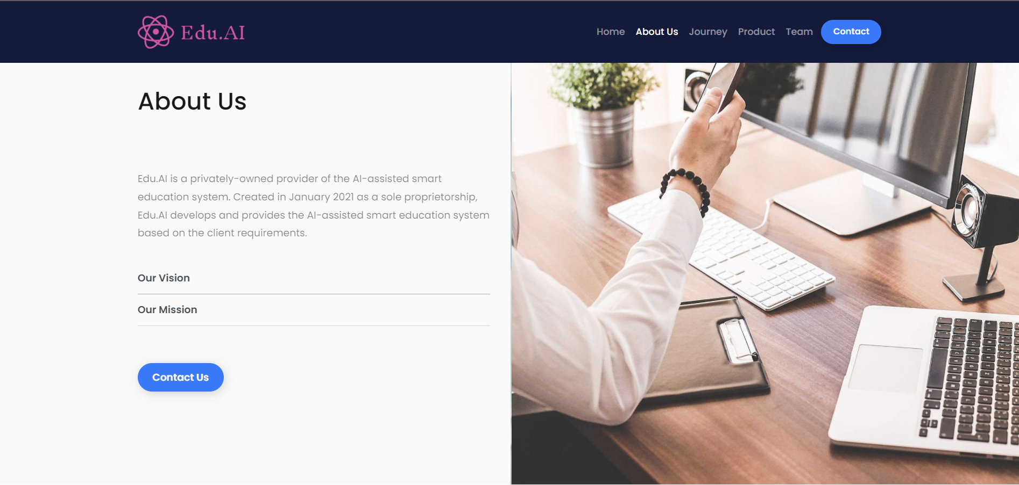

1. **Company’s Journey**

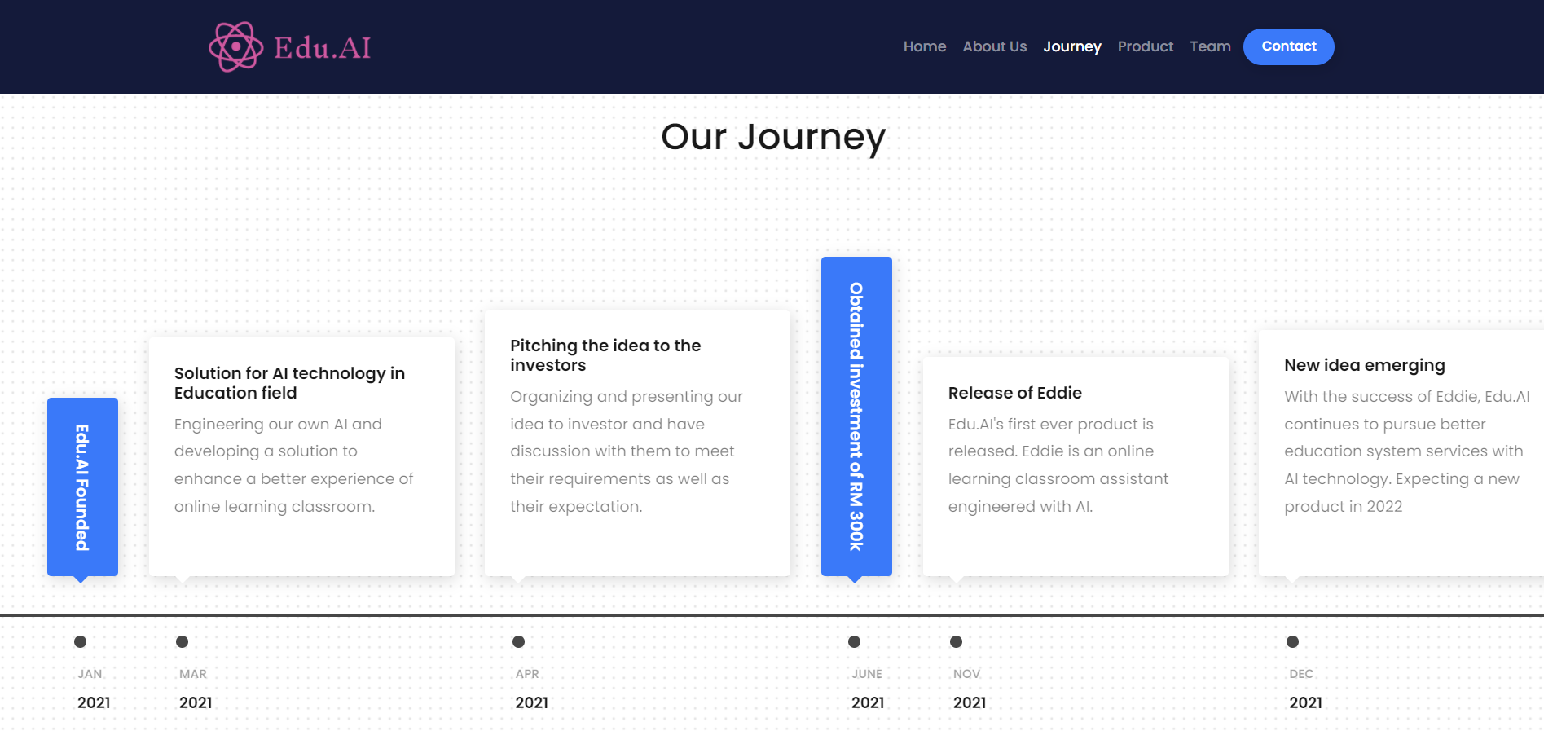

1. **Company’s Product**

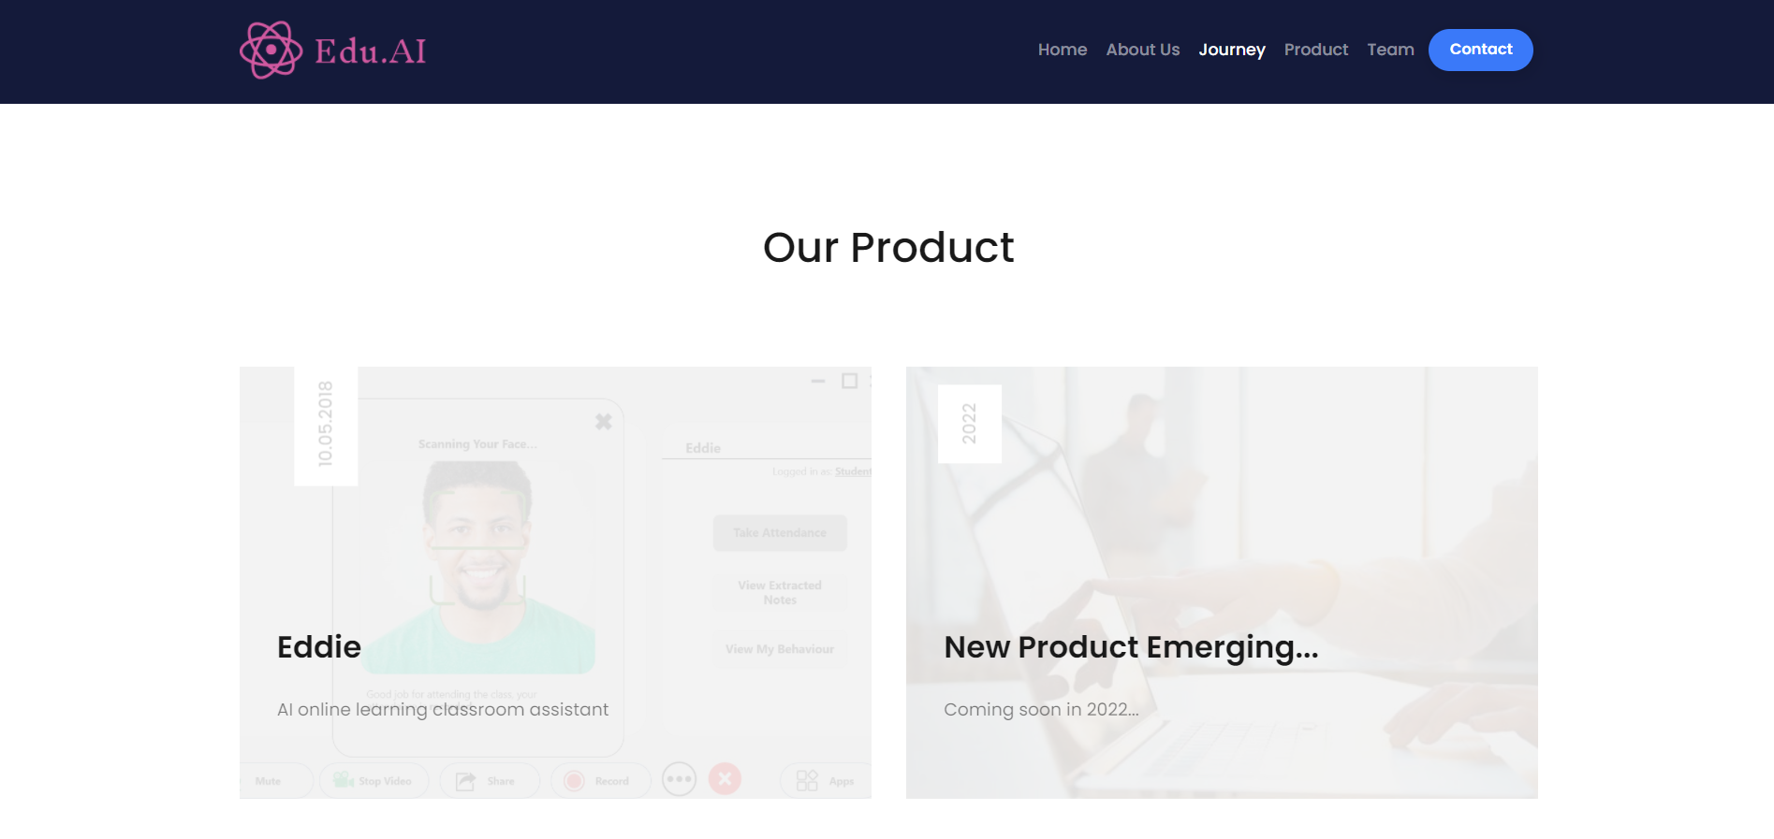

1. **Company’s Team**

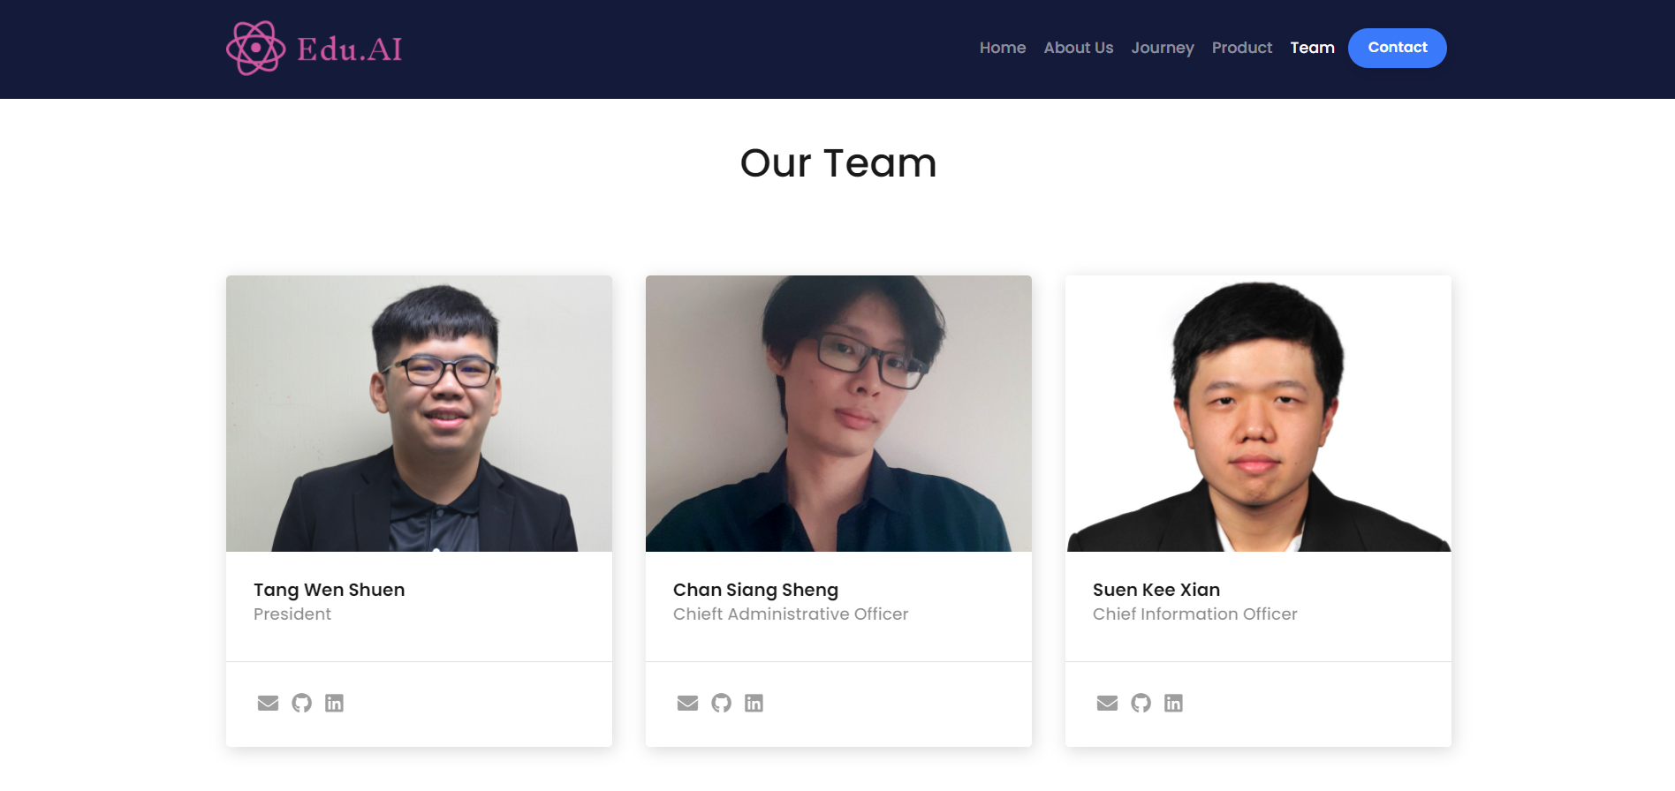

1. **Contact Us**

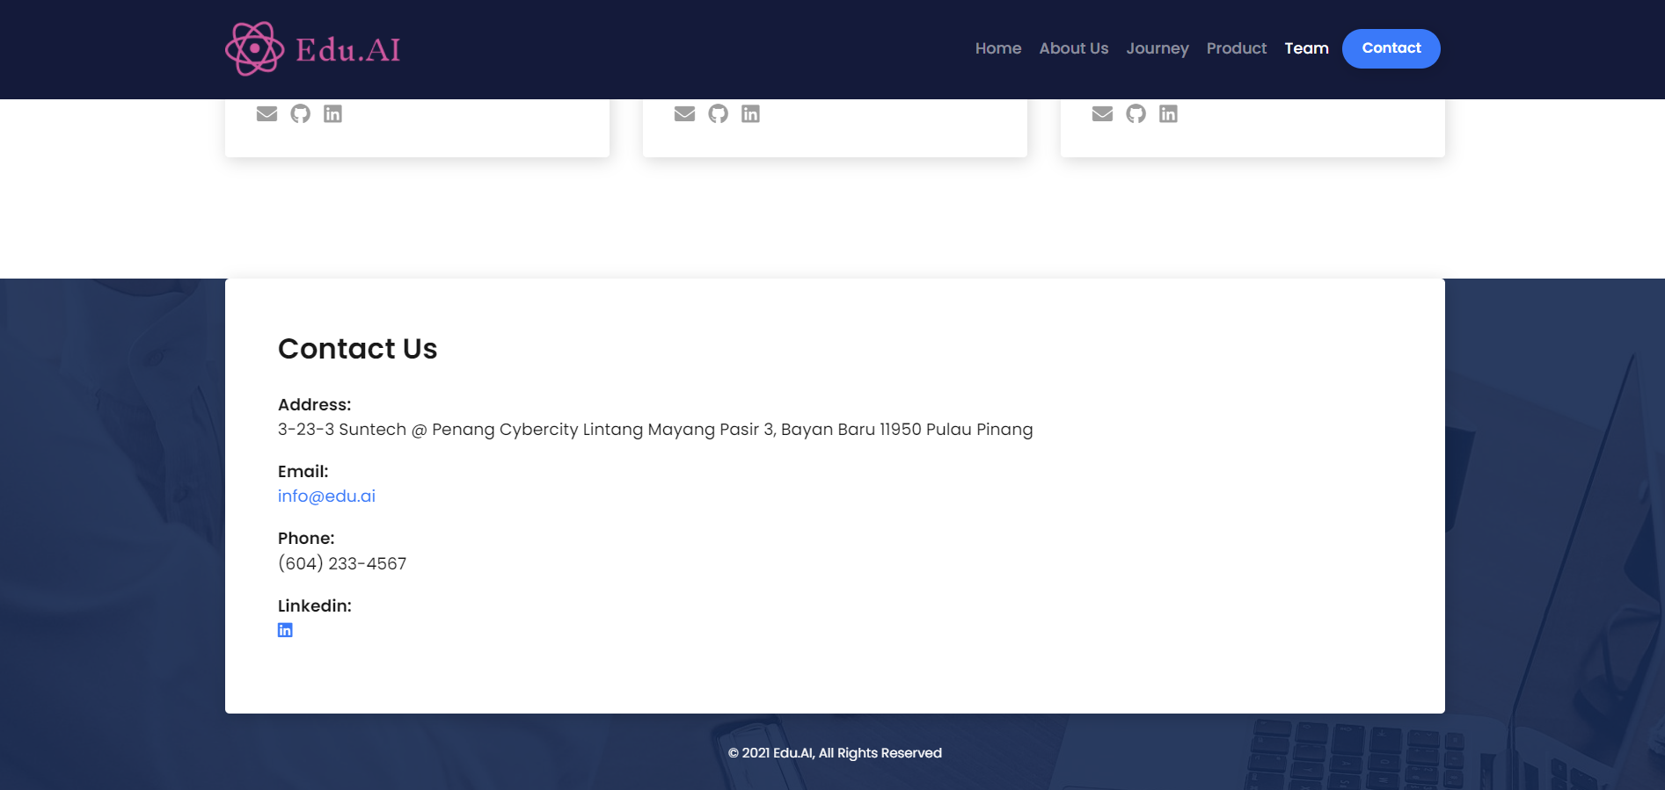

### Exhibit B: Eddie’s Features

1. **Student’s side**
2. Take student’s attendance

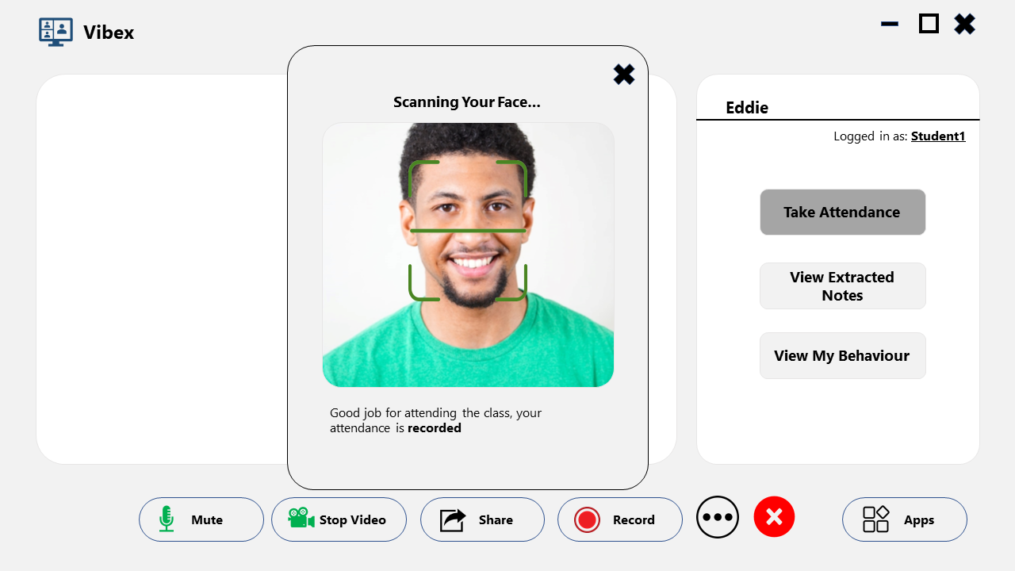

1. View extracted notes for the current lecture

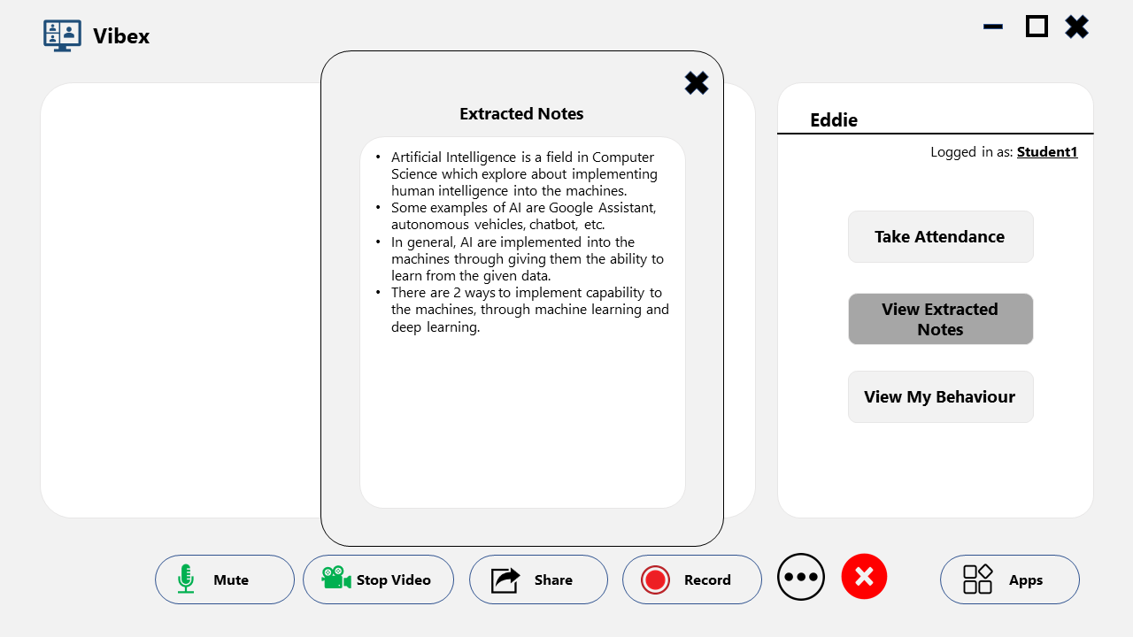

1. Monitor student’s behaviour

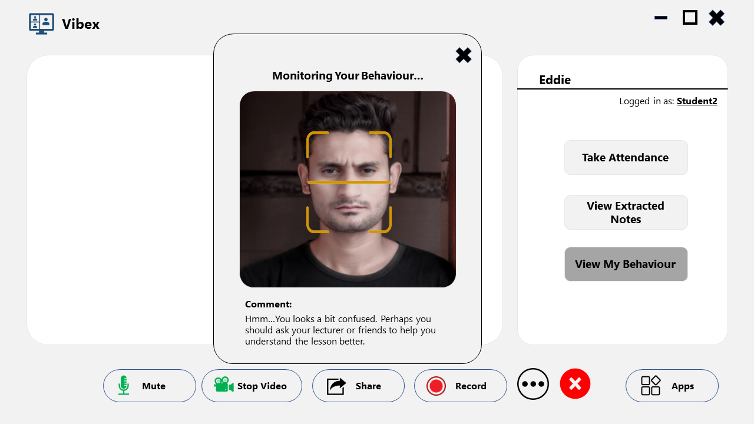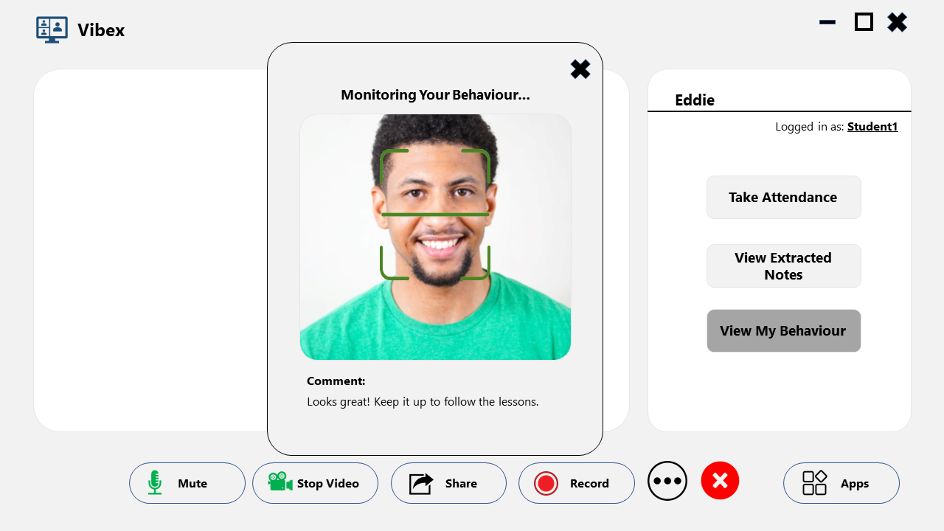

1. **Lecturer’s side**
2. View students’ attendance

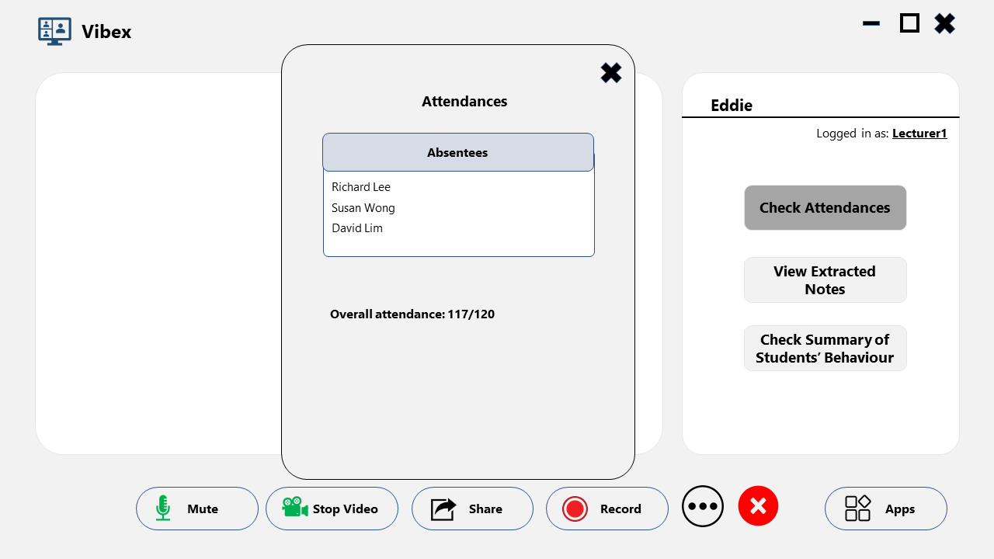

1. View extracted notes

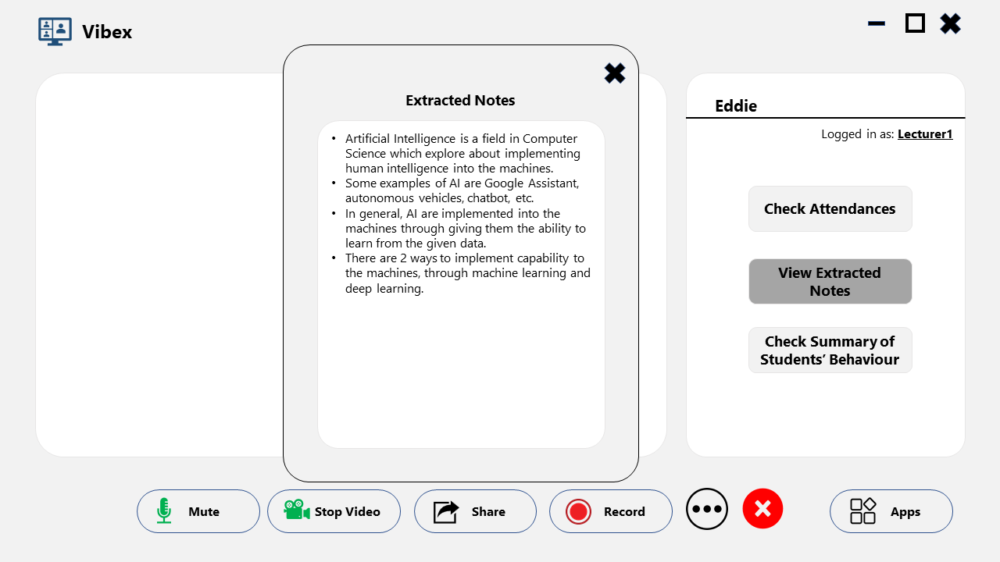

1. View a summary of students’ behavior

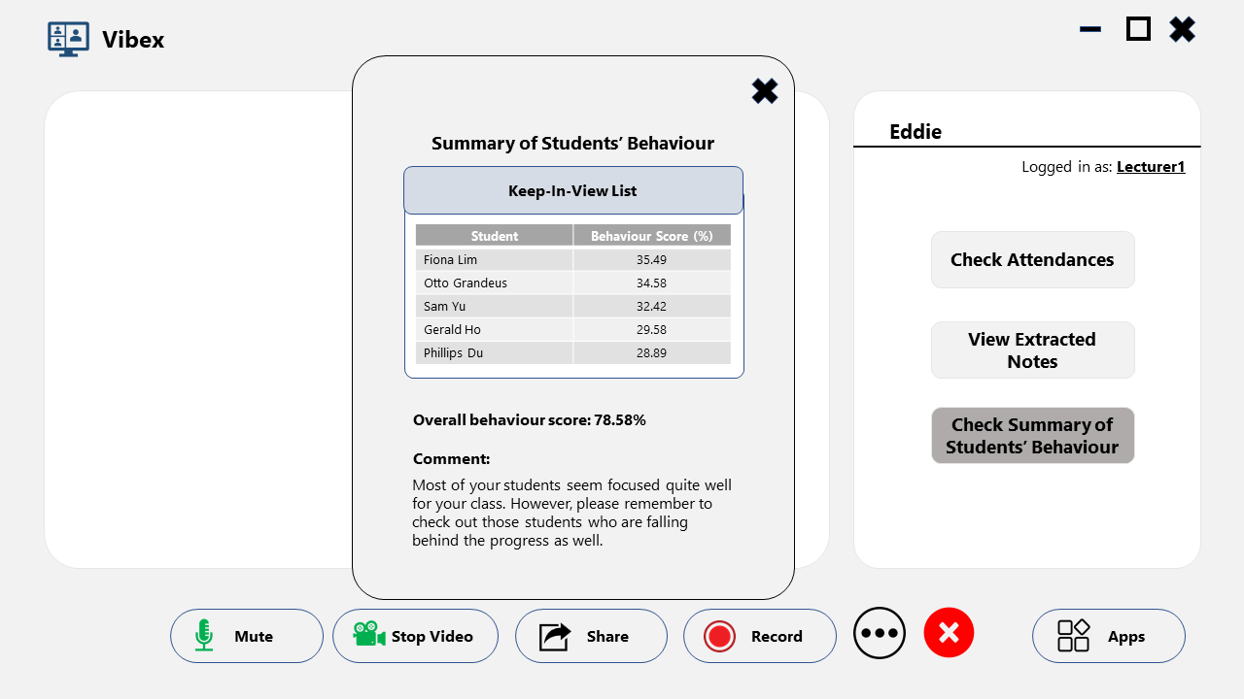

## 

## References

1. “E-Learning Market Trends 2021, Global Forecast Report 2027 - table of content,” Global Market Insights Inc. [Online]. Available: <https://www.gminsights.com/toc/detail/elearning-market-size>. [Accessed: 20-Jan-2022].
2. “Elearning statistics,” ThinkImpact.com, 18-Dec-2021. [Online]. Available: <https://www.thinkimpact.com/elearning-statistics/>. [Accessed: 20-Jan-2022].